Formulari de sol·licitud d’avaluació d’estudis al CEIm-PSMAR
Sol·licitant /Applicant
Nom i cognoms / Nameand Surname
Nom CRO (si aplica)
Name of CRO (if applicable)
Telf. |  |  | E-mail
Promotor / Sponsor
Nom / Name
Adreça / Adress:
Telf. |  |  | E-mail
Evaluation Request Form to the EC - PSMAR
Dades d’identificació de l’estudi / Study Identification
Títol / Title
Codi protocol / Protocol Code
Investigador Principal / coordinador (en estudis multicèntrics)
Principal Investigator / Coordinator
(in multicentre studies)
Investigador principal del centre /
Local principal Investigator
Servei/departamento/grup recerca
Service/department/research group
E-mail
Versió i data del protocol
Version and date of the protocol
Versió i data del FIP/CI
Version and date of the ICF
☐ Unicèntric / Unicentre
☐ Multicentre. Llistat de centres / list of sites participanting in the study (in the member state):

Nº total de participants
Total number of subjects
Nº participants previst al centre
Nº subjects planned in the centre
- RESUM / SUMMARY
Informació sobre els objectius i disseny de l’estudi (en llenguatge planer)
Provide information about the aims, scope and design of the study (in lay language):

Tipus d’estudi /  Study type | ☐ Assaig clínic / Clinical trial (RD1090/2015)  ☐ Baix Nivell Intervenció / Low Intervention Clinical Trial  ☐ amb medicaments autoritzats fora d’indicació de la fitxa tècnica /  the IMPs are NOT used in accordance with the terms of the marketing  authorisation  ☐ Investigació Clínica amb Producte Sanitari / Clinical Investigadtion with Medical Device  ☐ amb marcat CE / with CE mark  ☐ per estudiar una nova indicació / for a new indication  ☐ estudi clínic amb un producte alimentari o nutricional / nutritional intervention studies  ☐ estudi clínic sobre un procediment de diagnòstic, prevenció, cribatge o tractament / research trials for procedures to diagnose, prevent, screen for, or treatment  ☐ estudi clínic que requereix la realització de proves o intervencions invasives fora de la práctica clínica habitual / clinical study with invasive tests or interventions outside of routine clinical practice  ☐ estudi observacional amb medicaments / Post-authorization studies (PAS)  ☐ estudi observacional / observational studies  ☐ estudi observacional amb producte sanitari / observational Studies with medical devices  ☐ Other:……………………………………………………………………………….
Si es tracta d’un estudi acadèmic, indicar / Specify if this is an academic study:
☐ Yes
☐ No
If yes, specify (TFG, TFM, PhD, ...): ……………………………………………………………
L’estudi està aprovat per un altre Comitè d’Ètica? / The study has the approval of another Ethics Committee?
☐ Yes
☐ No
If yes, specify: ……………………………………………………………
** adjuntar el certificat d’aprovació amb la presentació de l’estudi / attach the certificate of approval with the study submission

- HUMAN BEINGS
Does your research involve human participants?  If Yes: |  | ☐ Yes ☐No
- Are they volunteers for social or human sciences research? |  | ☐ Yes ☐No
- Are they persons unable to give informed consent (including children/minors)? |  | ☐ Yes ☐No
- Are they vulnerable individuals or groups? |  | ☐ Yes ☐No
- Are they children/minors? |  | ☐ < 12 y  ☐12 -18 y
- Are they patients? |  | ☐ Yes ☐No
- Are they healthy volunteers for medical studies? |  | ☐ Yes ☐No
Details the recruitment procedures (if applicable):

Does your research involve physical interventions on the study participants?  If Yes: |  | ☐ Yes ☐No
- Does it involve invasive techniques (e.g. collection of human cells or tissues, surgical or medical interventions, invasive studies on the brain, TMS etc.)? |  | ☐ Yes ☐No
- Does it involve collection of biological samples?  If yes, complete section C. |  | ☐ Yes ☐No
Do you provide an informed consent form (ICF)?  If yes:  - General or main ICF  - For parents/legal representative  - Assent of the child  - Sub-study  - Others: …………………………………………………………….  If no, justify the exception to requiring the informed consent form:  - The research poses no more than minimal risk to subjects (a record review or using data from medical records)  - The rights and welfare of the individual would not be adversely affected  - It is impracticable to obtain consent  - The research does not infringe the principle of self-determination  - The waiver of informed consent is needed for the study  - The clinical relevance and public health importance  - Patient/participant signed a previous ICF that permits the secondary use of data and/or samples to future studies of the same line of research, and the previous study was approved by the ethics committee.  Other information of interest to the ethics committee (free text): |  | ☐ Yes ☐No  ☐  ☐  ☐  ☐  ☐  ☐  ☐  ☐  ☐  ☐  ☐  ☐
- HUMAN SAMPLES (if applicable):
Does your research involve Human Embryonic Stem Cells (hESCs)? | ☐Yes ☐No
Does your research involve the use of human embryos? | ☐ Yes ☐No
Does your research involve the use of human foetal tissues / cells? | ☐ Yes ☐No
Does your research involve human cells or tissues (other than from Human Embryos/Foetuses)?  If Yes: | ☐ Yes ☐No
- Are they available commercially? | ☐ Yes ☐No
- Are they obtained within this project? | ☐ Yes ☐No
- Are they obtained from another project, laboratory or institution? | ☐ Yes ☐No
- Are they obtained from a biobank? | ☐ Yes ☐No
Detail of the cells or tissue type, the source of the material, provider (biobank, hospital, company…), amount to be collected, duration of storage what you will do with the material at the end of the research, or if you will destroy samples at the end of the study:

Detail if material is fully anonymised or that consent for secondary use will be obtained:

- PERSONAL DATA PROTECTION
Personal Data: Information that can lead to the identification of an individual (or a group of individuals)
- Direct identifiers: name, address, postcode, telephone number, photograph or image, or some other unique personal characteristic, id card/social security number, medical record number …
- Indirect identifiers: when certain information is linked together with other sources of information, including, their place of work, job title, salary, their postcode or even the fact that they have a particular diagnosis or condition, date of birth, gender ….

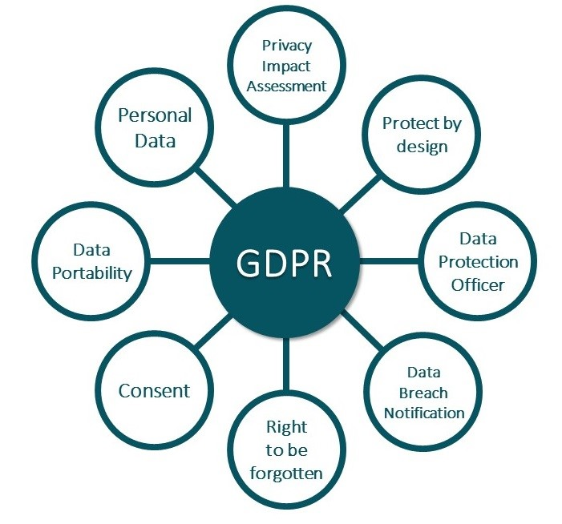

References:

Ley Orgánica 3/2018, de 5 de diciembre, de Protección de Datos Personales y garantía de los derechos digitales.

https://www.boe.es/buscar/doc.php?id=BOE-A-2018-16673

REGLAMENTO (UE) 2016/679 DEL PARLAMENTO EUROPEO Y DEL CONSEJO de 27 de abril de 2016 relativo a la protección de las personas físicas en lo que respecta al tratamiento de datos personales y a la libre circulación de estos datos.

https://eur-lex.europa.eu/legal-content/ES/TXT/?uri=celex%3A32016R0679

https://web.gencat.cat/ca/seu-electronica/sobre-la-seu/proteccio-de-dades

https://salutweb.gencat.cat/ca/el_departament/proteccio-de-dades/

https://apdcat.gencat.cat/ca/documentacio/RGPD/altres_documents_dinteres/

Does your research involve processing of personal data?  If Yes: | ☐ Yes ☐No
Does it involve the processing of special categories of personal data (e.g. genetic, health, sexual lifestyle, ethnicity, political opinion, religious or philosophical conviction)? | ☐ Yes ☐No
Does it involve processing of genetic, biometric or health data? | ☐ Yes ☐No
Does it involve profiling, systematic monitoring of individuals or processing of large scale of special categories of data, intrusive methods of data processing (such as, tracking, surveillance, audio and video recording, geolocation tracking etc.) or any other data processing operation that may result in high risk to the rights and freedoms of the research  participants? | ☐ Yes ☐No
Does your research involve further processing of previously collected personal data (including use of preexisting data sets or sources, merging existing data sets)?  Information to be provided in the protocol: details of the database used or of the source of the data, and data processing operations. | ☐ Yes ☐No
Is it planned to export personal data from the EU to non-EU countries? | ☐ Yes ☐No
Details of the technical and organisational measures to safeguard the rights of the research participants:

☐ Informed Consent Form (ICF)
☐ Anonymization: Process of removing private or confidential information from raw data. Results in anonymous data that cannot be associated with any individual or company. For data to be truly anonymised, the anonymisation must be irreversible.
☐ Pseudonymization: the processing of personal data in such a way that the data can no longer be attributed to a specific data subject without the use of additional information, as long as such additional information is kept separately and subject to technical and organizational measures to ensure non-attribution to an identified or identifiable individual.
Detail data protection officer (DPO) contact (in the institution): proteccodedades@imim.es
Detail Sponsor data protection officer (DPO) contact: ……………………………………………………….
Under the GDPR, a Data Protection Impact Assessment (DPIA) will be mandatory for any new high-risk processing projects. Type of research projects requiring a DPIA:

- Observational: unicentre or multicentre, prospective or retrospective, without informed consent form and/or when data is transferred to third parties.
- Innovative technologies: processing involving the use of new technologies, or the novel application of existing technologies. P. e: artificial intelligence, machine learning and deep learning, Smart technologies (including wearables), market research involving neuro-measurement (i.e. emotional response analysis and brain activity)
- Large-scale profiling: any profiling of individuals on a large scale. P.e.: data processed by Smart Meters, hardware/software offering fitness/lifestyle monitoring, social-media networks.
- Biometric data: any processing of biometric data for the purpose of uniquely identifying an individual. P.e.: facial recognition systems, workplace access systems/identity verification, access control/identity verification for hardware/applications (including voice recognition/fingerprint/facial recognition)
- Genetic data: any processing of genetic data. P.e.: medical diagnosis, DNA testing, medical research.
- Tracking: processing which involves tracking an individual’s geolocation or behaviour, including but not limited to the online environment. P.e.: social networks, software applications, hardware/software offering fitness/lifestyle/health monitoring, online advertising, web and cross-device tracking, data aggregation / data aggregation platforms, eye tracking, data processing at the workplace, data processing in the context of home and remote working, wealth profiling – identification of high net-worth individuals for the purposes of direct marketing.

- Agreement and study budget
An agreement will be necessary in multicenter studies (interventional, observational or clinical trial with new investigational products).

The study agreement will be managed through the IMIM Research Service, whose contact person is Mariola Vera.
- E-mail: mvera@imim.es, contractes@imim.es
- Telf. : 933160602

Note: template of the study agreements will be provided by Mariola Vera.

Study Budget (the estimated amount of money that you need to accomplish the goal of a clinical trial or research study):

☐ Not available (not funded)
☐ Funded study

Note: study budget must be submitted in funded studies.

The requirements for submitting studies to the Ethics Committee are available on the website:

https://www.imim.es/comitesetics/ceic/index.html

Specify the list all the documents attached:
- Request Form
- Protocol
- ICF
- Study Budget
- Reference ethics committee approval
- Investigator commitment
- …..
- …..
- …..
- …..

Submitted by: …………………………………
Date: …………………………………………..

